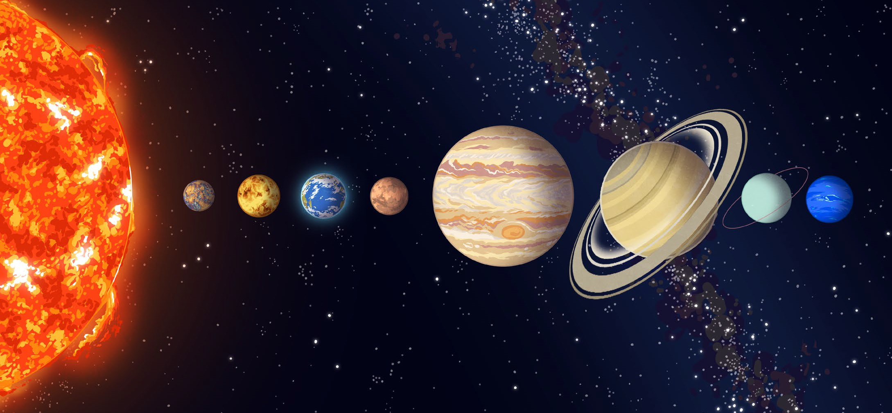
Mars | Earth | Neptune | Saturn
Jupiter | Uranus | Mercury | Venus
The Solar System
Use the word bank provided to label the parts of the solar system.

