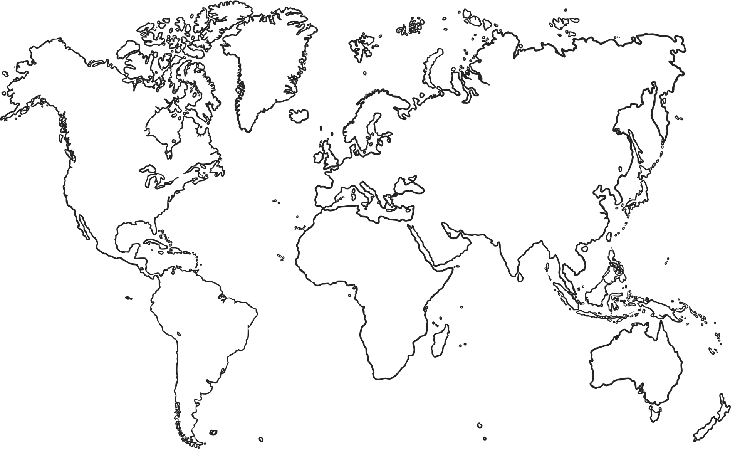
Find out India’s capital city and label it on the map.
Can you label any other major cities in India?
Label the country you live in on the world map.
Label India.
Which continent is India in?
Draw India’s flag.
Where Is India?

