Samosas
Ingredients
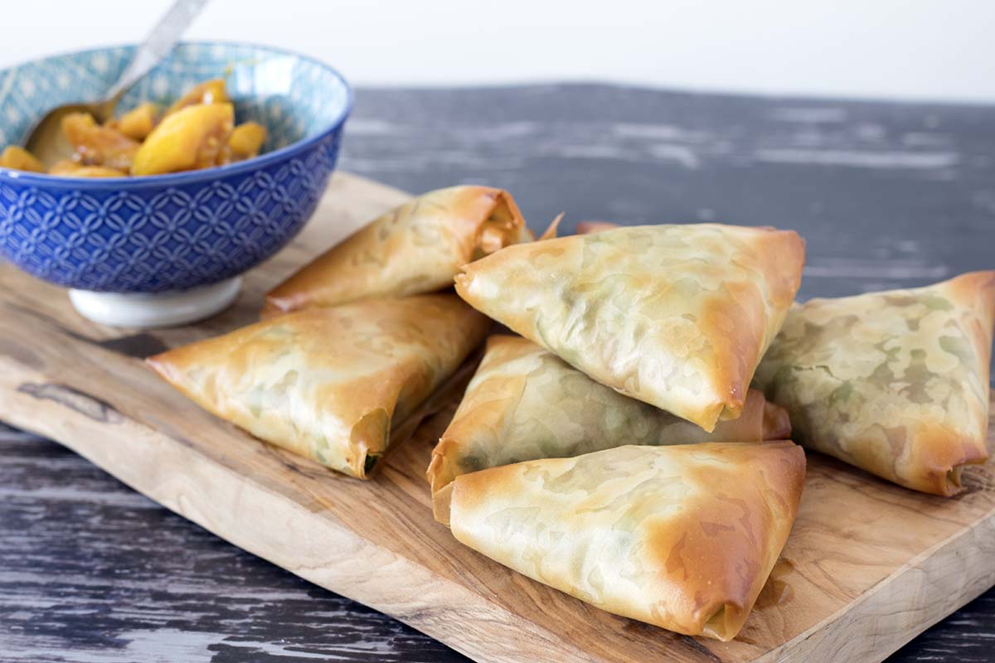
2 potatoes (large, cooked and mashed)
115g petit pois
filo pastry sheets
2 tsp curry powder (medium)
1 egg

Method
- Preheat the oven to 180'C/Gas mark 4/350'F
- Mix together the potatoes and peas and add in the curry powder
- Cut the pastry into fifteen 4 inch strips
- Beat the egg and brush the pastry sheets, do this by layering 4 sheets of filo pastry on top of each other brushing in between each sheet
- Spoon a little of the mixture near the bottom left corner of the pastry and begin to fold over into triangular shapes, until you come to the end of the strips
- Place on a greased and lined baking tray and brush the samosa with a little egg
- Cook in the oven for 15-20 minutes until flaky and golden brown

