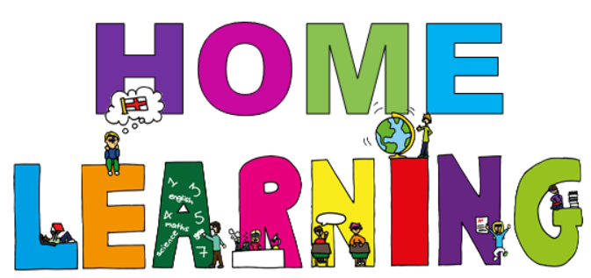

Week beginning 8th February 2021

Dear Willow & Ash parent(s)/carers,

Below are activities which can be completed at home. We have suggested subjects to be completed on certain days, which correspond with what we are completing at school. This said, if you would like to change the order of the lessons then you are welcome to do so. If you have any trouble accessing resources or if you have any questions, please do not hesitate to get in contact with us at school. Some of the activities will require access to a computer. If your child is unable to access a computer, please let us know and we can discuss how we can help.

Face to face Zoom sessions –
We would like to invite you to join us for 3 zoom sessions each week – details will be sent via email before each session, including login details and passwords.
Session 1 – Monday morning at 10:00 – 10:20 –Social session; pupils will have an opportunity to see their friends and share their weekend news.
Session 2 – Monday afternoon 1:30 – 2:00 - Explanation session for parents and pupils; to give you an opportunity to ask any questions or discuss home learning packs.
Session 3 – Thursday or Friday (times to be confirmed during our weekly phone calls or via email prior to the sessions) – Sharing session one to one face to face zoom session with the class teacher; pupils will have an opportunity to speak with their class teacher and show off their work.
Stay safe and well!
All the best,

Ash and Willow Class teachers

Timetable -
Here is a copy of our timetable at school, which has been slightly adapted to suit home learning:
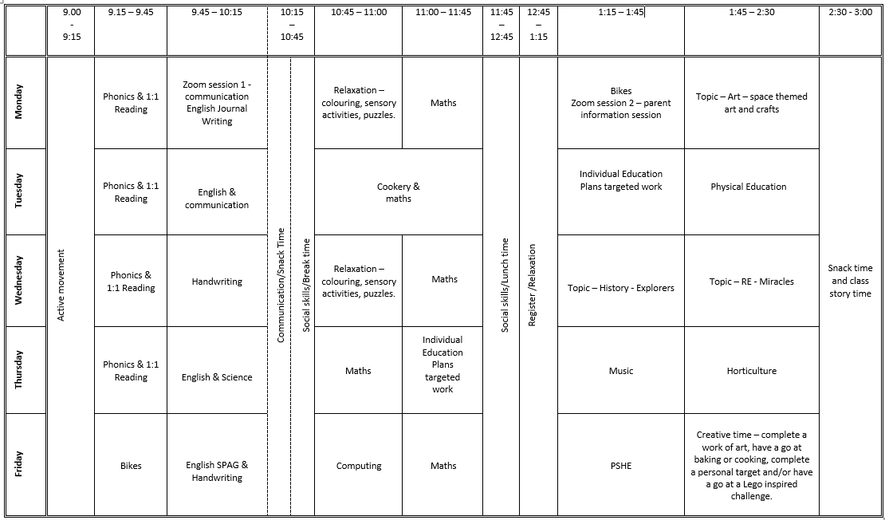

Monday home learning activities -
Subject | Activities that can be completed at home.
Active movement | Just Dance 2018 • Waka Waka (Football Version) - YouTube  Just Dance 2015 "Happy" - YouTube
Phonics | (If you need support with the pronunciation of the sounds you can listen to them on the following link Phase 2 Phonic Sound Help with Pronunciation - YouTube)  Introduce: We are learning the new letters m and d  Revisit: Sing alphabet song - Phonics Song 2 (new version) - YouTube and ask the child to write the alphabet on their whiteboard or order the letters using magnetic letters.  Login to phonicsplay.co.uk - PhonicsPlay Username: jan21 Password: home  Play flashcards: speed trial. Practise the sounds of the letters in phase 2 that your child finds tricky.  Teach: Introduce the new letters m and d.  Practise: practise writing the letters with your fingers in the air, on the carpet, on you back, on your whiteboard, with paper and pencil, with shaving foam etc.  Apply: play George’s gym – explain that Ted the teddy (use any favourite teddy or soft toy from your house) but she/he only talks in sound talk (sound talk is when you read a word by sounding out the letters – click on the link to see an example of this CVC Words | Phonics Phase 2 - YouTube) Use the toy/teddy to model taking a word card/picture card and sounding it out using sound talk. Ask your child to match the word to the picture. Example of words you can use are: am, man, mat, map, nip, pip, pin, tin, tan, nap.
Reading | Oxford Owl ebook Library – see separate leaflet for details –  https://www.oxfordowl.co.uk/login?active-tab=students  Ash & Willow –  Username: fitzwarynashwillow  Password: ashwillow  - Read a level appropriate book with your child.  - Share your favourite picture/chapter novel with them.
English | Weekend News Journal Writing.  You are welcome to join us on zoom at 10am for our weekly news social session. Details will be emailed prior to the session. Encourage your child to share their weekend news with the other pupils; encourage your child to ‘show and tell’ the other children something they have completed/made during the week, a picture they have painted in Art or a photo of them having fun outside. Please can we ask that your mic is muted when your child is not speaking to the group. Then ask your child to draw a picture of what they did at the weekend.  Extension: Ask your child to write a simple sentence or a few key words to accompany their picture. This can be done by copying a sentence you have written for them after they have told you what to write or overwriting a sentence that has been written for them in a felt tip pen.
Maths Learning intention:  - I can count, read and write numbers to 20.  Success criteria:  - pupils will count reliably up to 20.  -pupils will read numerals up to 20.  Pupils will write numbers up to 20.  -pupils will compare and order numbers to 100. | You will need: 1 – 5/10/20 number cards, washing line/string/wool, pegs, 1 – 5/10/20 number line.  Starter: Play Jack Hartman counting to 100 song on youtube - Let's Get Fit | Count to 100 | Count to 100 Song | Counting to 100 | Jack Hartmann - YouTube  Main teaching – Show your child your number line from 1-5/10 in order, point to the numbers on the line/washing line and say the numbers as you do so. Encourage your child to count with you.  Ask your child to close their eyes while you swop some two numbers on the washing line/number line. ‘No peeping! Which two numbers have been moved? How can you tell?’ Repeat with different numbers.  Quickly count from 1 to 5/10 in order, pointing to the numbers on the washing line as you do so. Remove all cards expect 1 and 5 but not pegs. Shuffle removed cards, take one at a time and ask your child to describe where to place them on the line.  Extension: use numbers up to 20 and beyond.  Group activity – show your child shuffled number cards, ask your child to pick a card and hand it to you face down. Say the number the child has chosen and ask the child to write it down on their whiteboards or count out that many objects. Turn over the card to reveal the number. Together check they have written the correct number or counted the correct number of objects. Repeat.  Simplify: As above but with numbers up to 5 or 10.  Activity – Ask your child to order the numbers from 1-5/10 to make a number line washing line using number cards, string/wool, and pegs. You could use the outside environment for this or the legs of a table.
Bikes/Physical movement | Go outside –  Ride a bike or walk around your local nature reserve or country park or play a game in your garden e.g., bat and ball, football, catch.
Topic - Art | 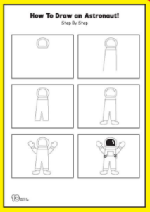  Astronaut in space art  Example:  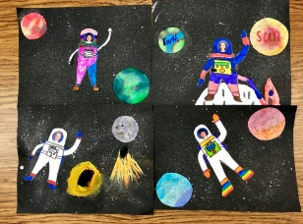  You will need: paper, water based felt tip pens, toothbrush/paintbrush, paint, black and white paper/card, scissors and glue, photo of child.  Step 1: Use a large cardboard box or tray to stop the paint for slattering everywhere. Put black paper in the box and then use a toothbrush/paintbrush dipped in paint to make the stars. Use your finger or a piece of card to flick the paint onto the black card.  Step 2: colour the planets using felt tip pens and paper, use could use planet templates for support. Then drop some water on them/spray them with water using a spray bottle to blend the colour together and get a watercolour effect.  Step 3: Then use the white paper to draw an astronaut, you could use a template for support. Encourage children to colour the astronaut any way they want. Then place a picture of them on the astronaut’s face. Cut them out ready to place of the picture.  Step 4: stick the planets and astronaut onto the black card to  complete their space pictures.

Tuesday home learning activities -
Subject | Activities that can be completed at home.
Active movement | Just Dance Kids 2 Jump Up - YouTube  5 Minute Move | Kids Workout 5 | The Body Coach TV - YouTube
Phonics | (If you need support with the pronunciation of the sounds you can listen to them on the following link Phase 2 Phonic Sound Help with Pronunciation - YouTube)  Practise: practise writing the letters with your fingers in the air, on the carpet, on you back, on your whiteboard, with paper and pencil, with shaving foam etc.  Revisit: Sing alphabet song - Phonics Song 2 (new version) - YouTube and ask the child to write the alphabet on their whiteboard or order the letters using magnetic letters.  Login to phonicsplay.co.uk - PhonicsPlay Username: jan21 Password: home  Play flashcards: speed trial. Practise the sounds of the letters in phase 2 that your child finds tricky.  Revise: the new letters m and d.  Play over the river. Have a piece of blue material/paper. Your child can choose to jump over it or have their favourite toy to do so. Use the cards from Monday. Give the child a choice of two and sound out the word m-a-p. Can they choose the correct card? Repeat as necessary. If they find this difficult have 2 words beginning with different sounds to make it easier to differentiate.  Extension: Have a choice of 4 cards with words beginning with the same sound.
Reading | Oxford Owl ebook Library – see separate leaflet for details –  https://www.oxfordowl.co.uk/login?active-tab=students  Ash & Willow –  Username: fitzwarynashwillow  Password: ashwillow  - Read a level appropriate book with your child.  - Share your favourite picture/chapter novel with them.
English - communication | Intro: go round circle saying hello and saying what they had for breakfast  Schools and Youth Groups - Children's Mental Health Week 2021 This link has ideas for creative activities and support suggestions for parents/carers.  Last week was child’s mental health week and we are continuing with some support activities. Today we are practising talking about our likes/dislikes.  Main: Go round circle taking it in turns to say our favourite colour, a food I don’t like, when I’m older I would like to……  Extension: Pretend we’re on an island for a day – what food would each pupil like to find, what music would they like to listen/dance to, what would they like to do all day.  Encourage your child to listen to everyone taking part.. Can they remember what everyone said.
Cooking/Maths  Learning intention:  To measure out ingredients correctly  Success criteria:  - I can use scales independently  I can use the correct mathematical terms when measuring ingredients | Encourage your child to help you prepare a meal this week. If possible, concentrate on your child helping to measure out the quantities. It’s good to model the mathematical vocabulary when measuring, for example grammes, litres, tablespoon etc.  This week we are cooking banana and blueberry muffins.  Cooking from around the world: banana and blueberry muffins Banana & blueberry muffins recipe - BBC Good Food  Pupils to measure the ingredients as independently as possible. Adults to model vocabulary – grammes, kilos, litres, centilitres, volume.  Pupils to be supported in using tools/knives correctly and safely while working as independently as possible.  Afterwards, encourage your child to wash up, put away and tidy up the kitchen.  
Individual Education Plan targeted work | Choose an activity to complete from your child’s individual education plan.
PE | Outside: go for a walk, run, bike ride, scooter ride.  Inside: there are online activities such as just dance or Joe Wickes PE sessions on youtube.  We finish off PE with a yoga session. We are using the one below this week but there are a wide range of choices under cosmic yoga on youtube.  Mike The Cosmic Space Monkey | A Cosmic Kids Yoga Adventure! - YouTube

Wednesday home learning activities -
Subject | Activities that can be completed at home.
Active movement | Just Dance Kids 2 Jump Up - YouTube  Just Dance Kids 2014 A Pirate You Shall Be - YouTube
Phonics | Introduce: We are Learning the phase 2 tricky words.  Revisit: Watch and sing Tricky Words and Sight Words Song - YouTube  Teach: Introduce unknown tricky words – to, I, no, go and into.  Practise: Practise writing the words with your fingers in the air, on the carpet, on the back of a member of the family, in the mud, in sand etc.  Apply: Make the words using play-dough. Complete the tricky words read and write activity sheet – phase 2.
Reading | Oxford Owl ebook Library – see separate leaflet for details –  https://www.oxfordowl.co.uk/login?active-tab=students  Ash & Willow –  Username: fitzwarynashwillow  Password: ashwillow  - Read a level appropriate book with your child.  - Share your favourite picture/chapter novel with them.
English & handwriting | (support/information for parents Nelson guide for parents | Oxford Owl)  Starter: 'I like to' playdough action song - YouTube – warm up ready for handwriting (you will need a blob of playdough)  Main: Watch Handwriting for kids. Learn to Write Lowercase Letters l, k, t, i, j - YouTube – use the video to practise writing the letters. Stop after each letter to practise witing it in their exercise books, on whiteboards, in sand, in shaving foam, using play-dough.
Maths  Learning intention:  - I can make estimates of numbers up to 5/10. | You will need: small objects, e.g. lego, animals, pasta, sweets, cubes etc, tray, towel/cloth to cover the tray.  Starter: watch and sing along to Let's Get Fit | Count to 100 | Count to 100 Song | Counting to 100 | Jack Hartmann - YouTube  Main teaching – prepare by spreading out a small pile of objects (up to 5/10) into a tray/pot and then cover with a towel or cloth. Tell the children that when you take away the cloth you want them to guess how many there are, but that they will not have time to count them. They will need to estimate how many there are. Remove the cloth for a few seconds and then replace it. Ask the children for their estimates. Then count the objects together. Discuss how to keep track when counting a large number of objects and suggest that you put them in a line or move the objects from one area to another in order to keep track when counting. Repeat with different number of objects.  Activity – children to take a large handful of objects and say how many they think they have, e.g. ‘I have 6.’ Then count them. Then find the number card to show how many objects they have counted. Challenge: see who can grab the largest number of objects in their hand without any falling out.  Extension: complete the how many objects? Sheet 1 – children to look at the objects and then estimate how many are there before counting to check.
Topic - History | Main - Intro this week’s explorer – Ibn Battuta.  Watch - History KS2 | Explorers: Ibn Battuta | BBC Teach - YouTube  Group Activity - Use Google Earth to explore all the cities and countries that Ibn Battuta visited. Talk about any ‘Wonders of the World’ that he would have seen on his travels, e.g. pyramids in Giza, Great Wall of China etc.  Activity – Ask your child to complete the worksheet by cutting out a few of the countries that Ibn visited and placing them on the map.
Topic - RE | You will need: bread, butter, jam, a plate and a knife.  Main: Discuss the story of Jesus feeding to 5000 using the lesson presentation and then watch the clip -  The miracle of the feeding of the 5000 - National 4 Religious, moral and philosophical studies - BBC Bitesize  Discuss: Jesus invited people to help him make a miracle happen. Who are the participants in the story who get to be a part of the miracle? Each of them needed to trust Jesus and have faith.  Which ways do we help people today? Charities? Friends and family shopping for vulnerable people. Online shopping.  Activity: Make a jam sandwich using bread, butter and jam.  Plenary: Your child can complete Mindfulness colouring worksheet.

Thursday home learning activities -
Subject | Activities that can be completed at home.
Active movement | Just Dance Kids 2 Jump Up - YouTube  5 Minute Move | Kids Workout 5 | The Body Coach TV - YouTube
Phonics | Introduce: We are Learning the phase 2 tricky words.  Revisit: Watch and sing Tricky Words and Sight Words Song - YouTube  Teach: Introduce unknown tricky words – to, I, no, go and into.  Practise: Practise writing the words with your fingers in the air, on the carpet, on the back  of a member of the family, in the mud, in sand etc  Apply: Play matching game with tricky words. Write/print them out twice and spread the  cards around. Can your child match the two words correctly. Say the word each time they  pick up a card.
Reading | Oxford Owl ebook Library – see separate leaflet for details –  https://www.oxfordowl.co.uk/login?active-tab=students  Ash & Willow –  Username: fitzwarynashwillow  Password: ashwillow  - Read a level appropriate book with your child.  Share your favourite picture/chapter novel with them.
English & Science  Learning Intention:  To recall facts about space  Success Criteria:  - I can remember a new fact about rocks  - I can write a sentence incorporating that fact. | The Solar System Song - YouTube  Recap from previous weeks. – what can they remember about the solar system.  Watch clip about the planets, stopping to check on each fact. What can the pupils remember?  https://www.youtube.com/watch?v=KCWxrTFh2Eg&ab_channel=KidsLearningVideos  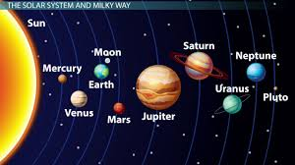  fun facts:  - There is a lot of difference between the planets. Some planets like Earth are made  - of rock, and some like Jupiter are made of gas. The hottest planet is Venus where  - the average temperature is 460°C, and the coldest is Uranus, which is -220°C.  - Mars is sometimes the called ‘the red planet’ because the rocks that it is made  - from are red. It is the closest planet to Earth,, and is slightly smaller than Earth.  - The biggest planet is Jupiter. Jupiter is made of gas and is so big that you could fit  1,321 planets the size of Earth inside it. There is even a storm on Jupiter that  - is bigger than Earth – this storm has been blowing for hundreds of years and is  called the ‘Great Red Spot’.  - Saturn is famous for having rings of small pieces of ice and dust around it.  - Like Jupiter, it is made of gas and is much bigger than Earth.  - Other planets have moons too. Jupiter has at least 66 of them.  Main: Using sand, flour, shaving foam or in the air write the names of some of the planets.  Extension: Using the writing sheet provided support your child to write some words  – the names of the planets.  The writing sheet is available on the website.  If your child is interested in space, then there are many more clips on youtube about rockets  and planets.
Maths  Learning intention:  To be able to state number bonds to 5  Success criteria:  I know what a number bond is  I know my number bonds to 5 | https://www.youtube.com/watch?v=lD9tjBUiXs0&ab_channel=JackHartmannKidsMusicChannel  Watch number bonds to 10 song  1:1 correspondence activities – concentrate on basics: number bonds to 10  Main: Number bonds to 5 – (5,0; 4,1; 3,2;2,3;4,1;0,5)  Using the frame provided put some counters or lego bricks down and count them with your  child. In the example provided you would count 2 and then support them to work out you need 3 more to make 5.  Extension: number bonds to 10.  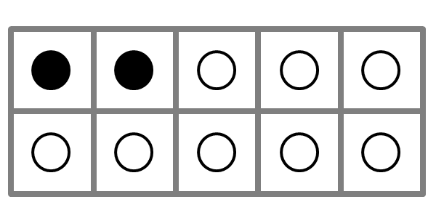
Music | Space songs with a difference – talk about films about space and the music associated  With them.  2001 Space Odyssey  https://www.youtube.com/results?search_query=2001+space+odyssey+theme  ET  https://www.youtube.com/watch?v=zREVZ6hsYQw&ab_channel=AwesomeSoundtracks96  Star wars  https://www.youtube.com/results?search_query=star+wars+theme  Did the music sound the same or different? How? Both composed by John Williams.  Compare to the planet suite music by Gustav Holst. If they have forgotten, replay a small  clip from Mars and Jupiter.  Which did they prefer? Why?
Horticulture  Learning Intention:  To check the results of an experiment and compare with the prediction  Success Criteria:  I can state what conditions seeds need to grow  I understand why seeds will/won’t grow in certain  conditions | Check cress seeds. Remind them of their predictions. Were they right? Which seeds  have grown the most? Why didn’t the other ones grow? Fill in the results on their sheets.  Explain we’re going to be planting vegetable seeds after half term. Explain that seeds  come in different shapes and sizes and that they’re not all the same.  Earthy Potatoes: how do potatoes grow? - YouTube  Seed potatoes can be bought from a garden centre, but any potatoes can be used. They  will sprout if left. Use an egg box and put a potato in each section. They will take about  6 weeks to sprout and then we will plant them in containers/bags of compost.  Let pupils handle the seed potatoes and point out the eyes. Explain how they grow into  shoots, before being planted. Compare this to the beans that we have grown. Look at  life cycle of a potato sheet and discuss how long it will take them to grow.  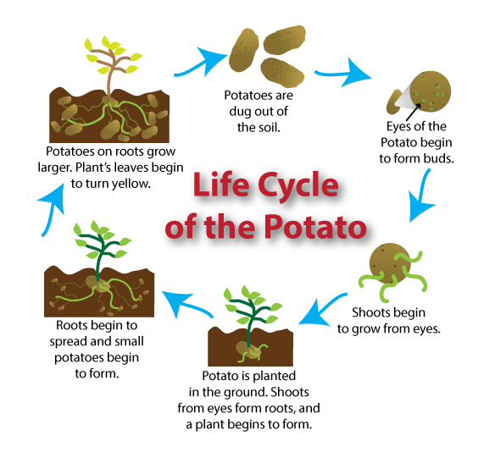  Compare this to the cress.

Friday home learning activities -
Subject | Activities that can be completed at home.
Active movement | Just Dance 2018 • Waka Waka (Football Version) - YouTube  Banana Banana Meatball - Blazer Fresh | GoNoodle - YouTube
Bikes | Go outside –  - Ride a bike.  - Have a walk around your local nature reserve or country park.  - Play a game in your garden e.g., bat and ball, football, catch.
English spelling, punctuation, grammar, and handwriting  Learning Intention:  -to use capital letters at the start of a sentence  Success Criteria:  -pupils will use the correct letter formation/size.  -pupils will include finger spaces, capital letters and full stops. | Starter: Watch and follow along to dough disco finger warm up - to warm up your child’s hands ready for writing.  Main: Parent/carer to write a sentence with a simple mistake i.e. without a capital letter at the start or full stop at the end. Can your child spot the mistake? You could ask them- does my sentence start with a capital letter? Does it end with a full stop? Have I spelt words used phonics to help me spell words? Have I put finger spaces between words?  Share English worksheet Friday’s semantics sheet with image of a spaceman. Ask your child to explain/discuss who, what doing, where? e.g. The alien is flying in space. Encourage your child to cut out the chosen word and stick it on the corresponding box, e.g. cut out alien and stick it on the ‘who?’ box.  Extension: When they have finished with the activity above ask your child to copy the sentence underneath, remembering to include the little words and a capital letter at the start of the sentence- The astronaut is standing on a rocket in space.
Computing | You will need: to download Kids Drawing, Doodle Painting app free from the app store.  Starter: Introduce the lesson using the technology song - Encourage your child to dance along.  Main: Use the internet to research the work of ‘Piet Mondrain’ and discuss what the child notice?  Demonstrate how to use the line and fill tools on a painting app to replicate his work.
Maths  Learning intention: I can count, read and write numbers to 5, 10 or 20. | Starter: Listen to Jack Hartman and then sing along.  Main: Show your child 5, 10 or 20 counters (or anything you can find at home). Model moving 1 counter at a time as you count the counters. Show numbers of counters, e.g. 5, 10, 15. Ask your child how many you are showing? Can they write the number on their whiteboards? How are they working it out?  Give your child counters. Can they use them to show you 5, 10, 15, 20, 6, 11, 12, 16 and 19?  Extension: Think about using groups of 5 to help.
PSHE | Creative Time- squishy soap  Ask your child to put the cornflour in the bowl and then add the wet ingredients. Mix until it forms a dough and then pour onto the table for your child to explore. It could be used for handwashing or bath time. You could place it in a lidded container between uses if you would like to keep it for longer.

Relaxation/mindfulness:
Guided Meditation for Children | Your Secret Treehouse | Relaxation for Kids - YouTube
Relax Music for Stress Relief, Study Music, Sleep Music, Meditation Music 💜 528Hz - YouTube
Guided Meditation for Kids | Spaceship to the Moon | Relaxation for Children - YouTube
Other helpful websites:
Home - GoNoodle
ictgames
PhonicsPlay
Welcome | Numeracy Warm Up
- username: fitzwaryn
- password: story
HelpKidzLearn
Writing warmups - dough disco for children - YouTube
Phonics song - Phonics Song 2 (new version) - YouTube
Jolly Phonics A-Z - YouTube
Counting song - Let's Get Fit | Count to 100 | Count to 100 Song | Counting to 100 | Jack Hartmann - YouTube
Space/planets song - The Solar System Song - YouTube

